KONGU ENGINEERING COLLEGE
(Autonomous), Perundurai, Tamil Nadu

DEPARTMENT OF INFORMATION TECHNOLOGY

24ITT32 – PROGRAMMING IN JAVA

INDIVIDUAL PROJECT REPORT
KEC ACADEMIC SYSTEM
Java JDBC and MySQL Based Academic Management System

Submitted by
SIRIN FATHIMA M I
Register Number: 25ITR136

Academic Year: 2026–2027

1. AIM
To develop a Java-based KEC Academic System using JDBC and MySQL to manage student academic information, attendance, assessment marks, and academic reports.

2. OBJECTIVE
To design and develop a database-driven Java application that supports student and course management, course enrollment, attendance tracking, CIA and ESE mark entry, semester mark sheets with SGPA, attendance defaulter reports, and department result summaries.

3. SOFTWARE REQUIREMENTS
- Java Development Kit (JDK) 17 or later
- Apache Maven
- MySQL Server 8.x
- MySQL Connector/J
- Command Prompt or Visual Studio Code

4. MODULES
Student Management: Adds student records with roll number, name, department, and current semester.
Course Management: Adds course code, title, credits, and course type.
Enrollment and Attendance: Enrolls a student in a course and records total classes, attended classes, and condonation status.
Assessment Marks: Enters or updates CIA-1, CIA-2, assignment/quiz/lab, and ESE marks.
Mark Sheet and SGPA: Displays course-level marks, attendance, grade, status, SGPA, and equivalent percentage.
Attendance Defaulter Report: Lists enrolled students whose attendance is below 65%.
Department Result Summary: Summarizes pass/fail counts and average SGPA by department.

5. PROCEDURE
- Create the MySQL database and tables by executing the supplied kec_schema.sql script.
- Configure the MySQL connection details in DBConnection.java.
- Open Command Prompt and change to the project folder containing pom.xml.
- Run Maven to clean and compile the project and execute MainApp.
- Choose a menu option and enter the requested student, course, attendance, or marks data.
- View the generated academic report and capture the actual console output for documentation.

6. FLOW OF EXECUTION
Start → Display Main Menu → Select Module → Read User Input → Connect to MySQL → Validate and Store/Retrieve Data → Display Confirmation/Report → Return to Main Menu → Exit

7. DATABASE SCHEMA
Database name: kec_academic
Table | Main fields
students | roll_no (PK), student_name, department, current_semester
courses | course_code (PK), title, credits, course_type
enrollments | enrollment_id (PK), roll_no (FK), course_code (FK), semester, total_classes, classes_attended, medical_condonation
assessment_marks | enrollment_id (PK/FK), cia1, cia2, assignment_mark, ese_mark, ese_absent, updated_at

8. EXECUTION COMMAND
Open CMD and run these commands:
cd /d "C:\Users\Smile\Downloads\KEC-Academic-System\KEC-Academic-System"
"C:\Users\Smile\Downloads\apache-maven-3.10.0-bin\apache-maven-3.10.0\bin\mvn.cmd" clean compile exec:java -Dexec.mainClass=com.kec.academic.MainApp
The application displays the KEC R2024 Academic System menu. Select the required option and enter the prompted values.

9. OUTPUT SCREENSHOTS
Figure 1: Main Menu. The screenshot supplied by the student confirms that Maven compiled the project and the application displayed the menu.
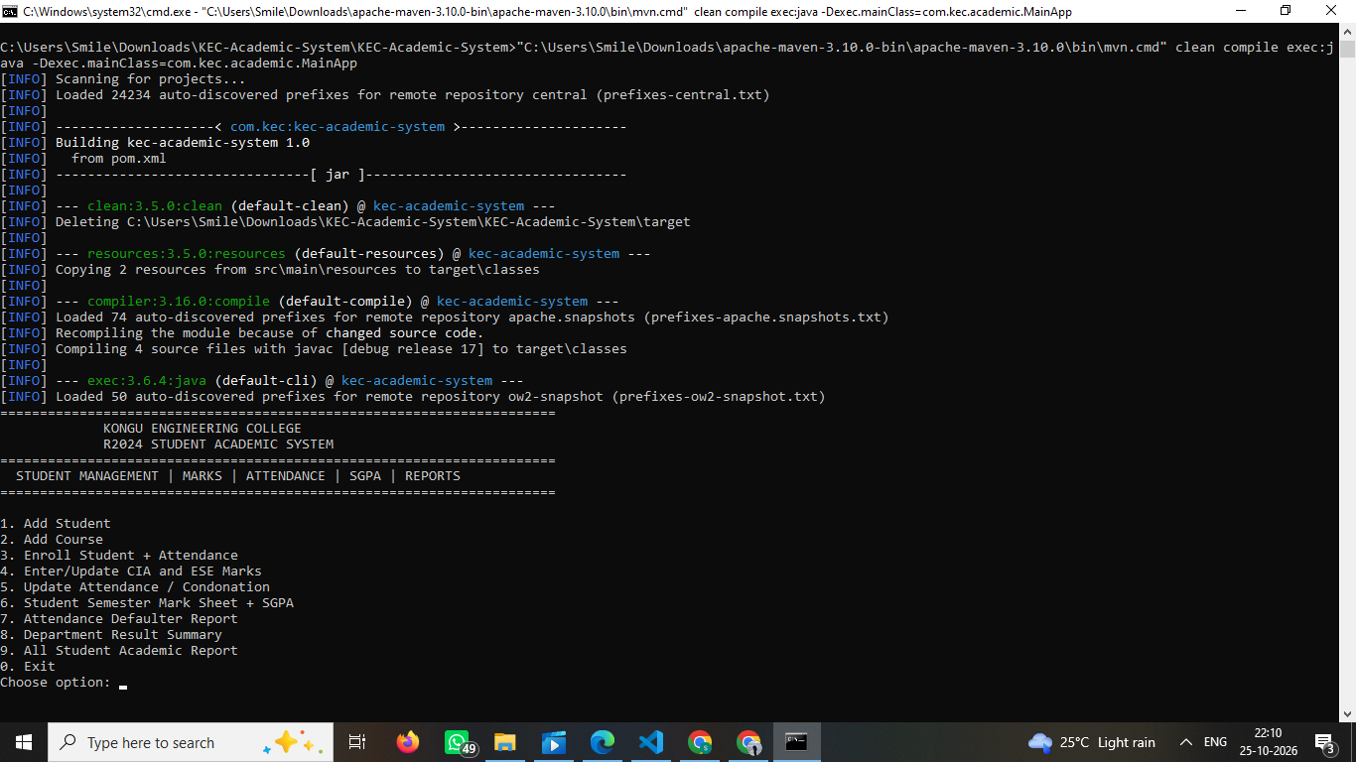
Figure 1: Main Menu of KEC Academic System

Figure 2: Add Student (Option 1)
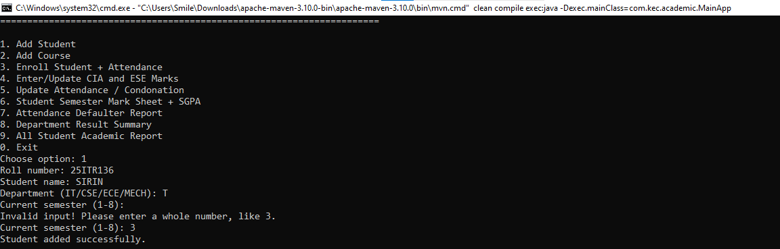

Figure 3: Add Course (Option 2)
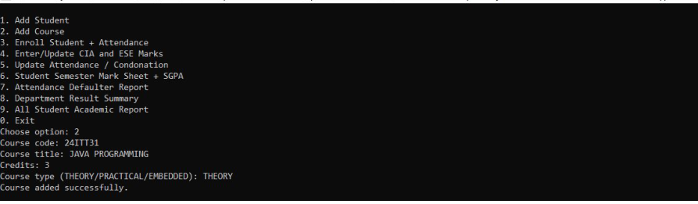

Figure 4: Enroll Student and Attendance (Option 3)
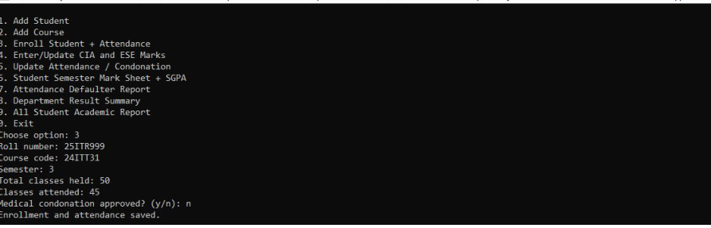

Figure 5: Enter/Update CIA and ESE Marks (Option 4)
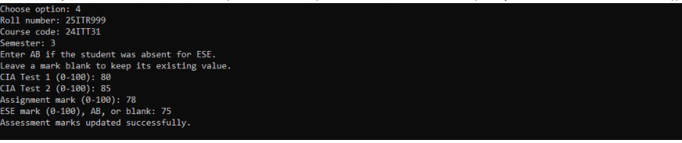

Figure 6: Update Attendance / Condonation (Option 5)
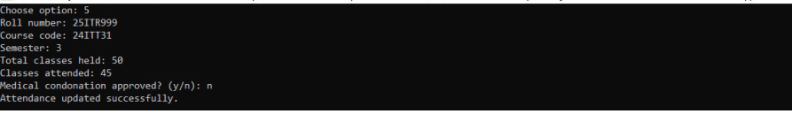

Figure 7: Student Semester Mark Sheet and SGPA (Option 6)
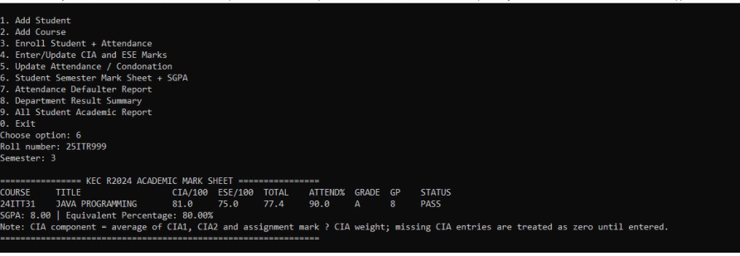

Figure 8: Attendance Defaulter Report (Option 7)
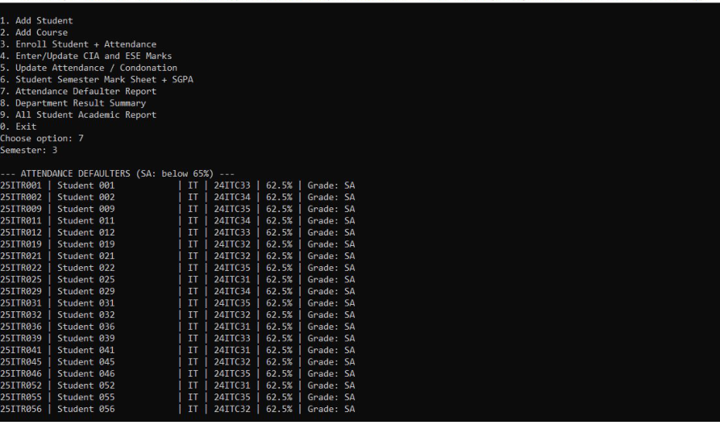

Figure 9: Department Result Summary (Option 8)
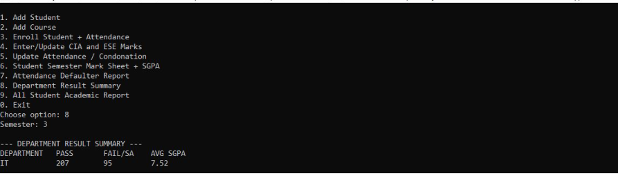

Figure 10: All Student Academic Report (Option 9)
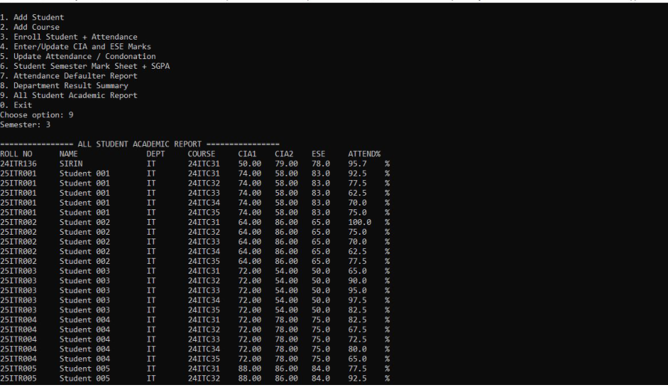

10. SOURCE CODE
The following appendix is taken from the uploaded project ZIP. DBConnection.java contains a placeholder password, which must be replaced locally with the actual MySQL password and must not be published as a secret.

MainApp.java
package com.kec.academic;

import java.sql.SQLException;
import java.util.Scanner;

public class MainApp {
private static final Scanner in = new Scanner(System.in);
private static final StudentDAO students = new StudentDAO();
private static final AcademicDAO academic = new AcademicDAO();

public static void main(String[] args) {
System.out.println("====================================================");
System.out.println(" KONGU ENGINEERING COLLEGE - R2024 ACADEMIC SYSTEM");
System.out.println("====================================================");
while (true) {
System.out.println("\n1. Add Student\n2. Add Course\n3. Enroll Student + Attendance\n4. Enter/Update CIA and ESE Marks\n5. Update Attendance / Condonation\n6. Student Semester Mark Sheet + SGPA\n7. Attendance Defaulter Report\n8. Department Result Summary\n0. Exit");
int choice = number("Choose option: ");
try {
switch (choice) {
case 1 -> addStudent(); case 2 -> addCourse(); case 3 -> enroll();
case 4 -> marks(); case 5 -> attendance(); case 6 -> academic.printMarkSheet(read("Roll number: "), number("Semester: "));
case 7 -> academic.printAttendanceDefaulters(number("Semester: "));
case 8 -> academic.printClassSummary(number("Semester: "));
case 0 -> { System.out.println("Application closed."); return; }
default -> System.out.println("Invalid menu option.");
}
} catch (SQLException | IllegalArgumentException ex) {
System.out.println("ERROR: " + ex.getMessage());
}
}
}
private static void addStudent() throws SQLException {
String roll=read("Roll number (e.g. 24ITR001): ").toUpperCase();
String name=read("Student name: "); String dept=read("Department (IT/CSE/ECE/MECH): ").toUpperCase();
int sem=number("Current semester (1-8): "); students.addStudent(roll,name,dept,sem);System.out.println("Student added successfully.");
}
private static void addCourse() throws SQLException {
String code=read("Course code (e.g. 24ITR31): ").toUpperCase();String title=read("Course title: ");double credits=decimal("Credits: ");
String type=read("Course type (THEORY/PRACTICAL/EMBEDDED): ").toUpperCase();students.addCourse(code,title,credits,type);System.out.println("Course added successfully.");
}
private static void enroll() throws SQLException {
String roll=read("Roll number: ").toUpperCase(),course=read("Course code: ").toUpperCase();int sem=number("Semester: ");
int total=number("Total classes held: "),att=number("Classes attended: ");boolean cond=yes("Medical condonation approved? (y/n): ");
academic.enroll(roll,course,sem,total,att,cond);System.out.println("Enrollment and initial attendance saved.");
}
private static void marks() throws SQLException {
String roll=read("Roll number: ").toUpperCase(),course=read("Course code: ").toUpperCase();int sem=number("Semester: ");
System.out.println("Leave a mark blank to keep its existing value. Enter AB for absent ESE.");
Double c1=optionalMark("CIA Test 1 (0-100): "),c2=optionalMark("CIA Test 2 (0-100): "),ass=optionalMark("Assignment/Quiz/Lab mark (0-100): ");
String eseText=read("ESE mark (0-100), AB, or blank to keep: ");boolean absent=eseText.equalsIgnoreCase("AB");Double ese=eseText.isBlank()||absent?null:parseMark(eseText);
academic.updateMarks(roll,course,sem,c1,c2,ass,ese,absent);System.out.println("Assessment marks updated successfully.");
}
private static void attendance() throws SQLException {
String roll=read("Roll number: ").toUpperCase(),course=read("Course code: ").toUpperCase();int sem=number("Semester: ");int total=number("Total classes held: "),att=number("Classes attended: ");boolean cond=yes("Medical condonation approved? (y/n): ");
academic.updateAttendance(roll,course,sem,total,att,cond);System.out.println("Attendance updated successfully.");
}
private static Double optionalMark(String prompt){String s=read(prompt);return s.isBlank()?null:parseMark(s);}
private static Double parseMark(String s){double d=Double.parseDouble(s);if(d<0||d>100)throw new IllegalArgumentException("Marks must be between 0 and 100.");return d;}
private static String read(String p){System.out.print(p);return in.nextLine().trim();}
private static int number(String p){return Integer.parseInt(read(p));}
private static double decimal(String p){return Double.parseDouble(read(p));}
private static boolean yes(String p){return read(p).equalsIgnoreCase("y");}
}

StudentDAO.java
package com.kec.academic;

import java.sql.Connection;
import java.sql.PreparedStatement;
import java.sql.SQLException;

public class StudentDAO {
public void addStudent(String roll, String name, String dept, int semester) throws SQLException {
String sql = "INSERT INTO students(roll_no,student_name,department,current_semester) VALUES(?,?,?,?)";
try (Connection con = DBConnection.getConnection(); PreparedStatement ps = con.prepareStatement(sql)) {
ps.setString(1, roll); ps.setString(2, name); ps.setString(3, dept); ps.setInt(4, semester);
ps.executeUpdate();
}
}

public void addCourse(String code, String title, double credits, String type) throws SQLException {
String sql = "INSERT INTO courses(course_code,title,credits,course_type) VALUES(?,?,?,?)";
try (Connection con = DBConnection.getConnection(); PreparedStatement ps = con.prepareStatement(sql)) {
ps.setString(1, code); ps.setString(2, title); ps.setDouble(3, credits); ps.setString(4, type.toUpperCase());
ps.executeUpdate();
}
}
}

AcademicDAO.java
package com.kec.academic;

import java.sql.*;

public class AcademicDAO {
public void enroll(String roll, String course, int semester, int total, int attended, boolean condonation) throws SQLException {
if (total < 0 || attended < 0 || attended > total) throw new IllegalArgumentException("Attendance values are invalid.");
String sql = "INSERT INTO enrollments(roll_no,course_code,semester,total_classes,classes_attended,medical_condonation) VALUES(?,?,?,?,?,?)";
try (Connection c=DBConnection.getConnection(); PreparedStatement p=c.prepareStatement(sql, Statement.RETURN_GENERATED_KEYS)) {
p.setString(1,roll); p.setString(2,course); p.setInt(3,semester); p.setInt(4,total); p.setInt(5,attended); p.setBoolean(6,condonation); p.executeUpdate();
try(ResultSet r=p.getGeneratedKeys()) { if(r.next()) ensureMarksRow(c,r.getInt(1)); }
}
}
private void ensureMarksRow(Connection c, int id) throws SQLException {
try(PreparedStatement p=c.prepareStatement("INSERT INTO assessment_marks(enrollment_id) VALUES(?)")) { p.setInt(1,id); p.executeUpdate(); }
}
private int enrollmentId(String roll, String course, int sem) throws SQLException {
String sql="SELECT enrollment_id FROM enrollments WHERE roll_no=? AND course_code=? AND semester=?";
try(Connection c=DBConnection.getConnection(); PreparedStatement p=c.prepareStatement(sql)) {
p.setString(1,roll); p.setString(2,course); p.setInt(3,sem);
try(ResultSet r=p.executeQuery()){if(r.next())return r.getInt(1);}
}
throw new SQLException("Enrollment not found. Enroll the student in this course first.");
}
public void updateMarks(String roll,String course,int sem,Double cia1,Double cia2,Double assignment,Double ese,boolean absent) throws SQLException {
if(absent && ese != null) throw new IllegalArgumentException("For AB, leave ESE mark empty.");
validateMark(cia1); validateMark(cia2); validateMark(assignment); validateMark(ese);
int id=enrollmentId(roll,course,sem);
String sql="UPDATE assessment_marks SET cia1=COALESCE(?,cia1),cia2=COALESCE(?,cia2),assignment_mark=COALESCE(?,assignment_mark),ese_mark=?,ese_absent=? WHERE enrollment_id=?";
try(Connection c=DBConnection.getConnection();PreparedStatement p=c.prepareStatement(sql)) {
setNullable(p,1,cia1); setNullable(p,2,cia2); setNullable(p,3,assignment); setNullable(p,4,absent?null:ese); p.setBoolean(5,absent); p.setInt(6,id); p.executeUpdate();
}
}
private void validateMark(Double x) { if(x!=null && (x<0 || x>100)) throw new IllegalArgumentException("Marks must be between 0 and 100."); }
private void setNullable(PreparedStatement p,int index,Double x)throws SQLException { if(x==null)p.setNull(index,Types.DECIMAL);else p.setDouble(index,x); }

public void updateAttendance(String roll,String course,int sem,int total,int attended,boolean condonation)throws SQLException {
if(total<0||attended<0||attended>total)throw new IllegalArgumentException("Attendance values are invalid.");
String sql="UPDATE enrollments SET total_classes=?,classes_attended=?,medical_condonation=? WHERE roll_no=? AND course_code=? AND semester=?";
try(Connection c=DBConnection.getConnection();PreparedStatement p=c.prepareStatement(sql)) {p.setInt(1,total);p.setInt(2,attended);p.setBoolean(3,condonation);p.setString(4,roll);p.setString(5,course);p.setInt(6,sem);if(p.executeUpdate()==0)throw new SQLException("Enrollment not found.");}
}

private String grade(double total) { if(total>=91)return "O";if(total>=81)return "A+";if(total>=71)return "A";if(total>=61)return "B+";if(total>=50)return "B";return "RA"; }
private int points(String g) { return switch(g){case "O"->10;case "A+"->9;case "A"->8;case "B+"->7;case "B"->6;default->0;}; }

public void printMarkSheet(String roll,int sem)throws SQLException {
String sql="SELECT s.roll_no,s.student_name,s.department,e.semester,e.total_classes,e.classes_attended,e.medical_condonation,c.course_code,c.title,c.credits,c.course_type,m.cia1,m.cia2,m.assignment_mark,m.ese_mark,m.ese_absent FROM enrollments e JOIN students s ON s.roll_no=e.roll_no JOIN courses c ON c.course_code=e.course_code JOIN assessment_marks m ON m.enrollment_id=e.enrollment_id WHERE s.roll_no=? AND e.semester=? ORDER BY c.course_code";
double weightedPoints=0,credits=0;boolean found=false;
System.out.println("\n================ KEC R2024 ACADEMIC MARK SHEET ================");
System.out.printf("%-10s %-22s %-8s %-8s %-8s %-8s %-6s %-5s %-5s%n","COURSE","TITLE","CIA/100","ESE/100","TOTAL","ATTEND%","GRADE","GP","STATUS");
try(Connection c=DBConnection.getConnection();PreparedStatement p=c.prepareStatement(sql)) {
p.setString(1,roll);p.setInt(2,sem);
try(ResultSet r=p.executeQuery()) { while(r.next()) { found=true;
String type=r.getString("course_type");double credit=r.getDouble("credits");int totalClasses=r.getInt("total_classes"),attended=r.getInt("classes_attended");
double attendance=totalClasses==0?0:100.0*attended/totalClasses;
Double a=nullable(r,"cia1"),b=nullable(r,"cia2"),d=nullable(r,"assignment_mark"),ese=nullable(r,"ese_mark");
boolean absent=r.getBoolean("ese_absent"),cond=r.getBoolean("medical_condonation");
double ciaAverage=average(a,b,d); double ciaWeight=type.equals("THEORY")?.40:type.equals("PRACTICAL")?.60:.50;
double eseWeight=1-ciaWeight; double eseThreshold=type.equals("THEORY")?27:type.equals("PRACTICAL")?20:22.5;
double ciaComponent=ciaAverage*ciaWeight; double eseComponent=ese==null?0:ese*eseWeight;double total=ciaComponent+eseComponent;
String g,status;boolean eligible=attendance>=75||(attendance>=65&&cond);
if(attendance<65){g="SA";status="BARRED";}else if(attendance<75&&!cond){g="SA";status="CONDONATION NEEDED";}else if(absent){g="AB";status="FAIL";}else if(ese==null){g="PENDING";status="ESE PENDING";}else if(eseComponent<eseThreshold||total<50){g="RA";status="FAIL";}else{g=grade(total);status="PASS";}
int gp=points(g);if(!g.equals("PENDING")){weightedPoints+=credit*gp;credits+=credit;}
String ciaText=(a==null&&b==null&&d==null)?"-":String.format("%.1f",ciaAverage);
String eseText=absent?"AB":ese==null?"-":String.format("%.1f",ese);
String totalText=g.equals("PENDING")?"-":String.format("%.1f",total);
System.out.printf("%-10s %-22.22s %-8s %-8s %-8s %-8.1f %-6s %-5d %-5s%n",r.getString("course_code"),r.getString("title"),ciaText,eseText,totalText,attendance,g,gp,status);
}}
}
if(!found){System.out.println("No enrollments found for this roll number and semester.");return;}
double sgpa=credits==0?0:weightedPoints/credits;
System.out.printf("SGPA: %.2f | Equivalent Percentage: %.2f%%%n",sgpa,sgpa*10);
System.out.println("Note: CIA component = average of CIA1, CIA2 and assignment mark × CIA weight; missing CIA entries are treated as zero until entered.");
System.out.println("===============================================================\n");
}
private Double nullable(ResultSet r,String col)throws SQLException {double x=r.getDouble(col);return r.wasNull()?null:x;}
private double average(Double... values){double sum=0;for(Double v:values)sum+=(v==null?0:v);return sum/values.length;}

public void printAttendanceDefaulters(int sem)throws SQLException {
String sql="SELECT s.roll_no,s.student_name,s.department,e.course_code,e.total_classes,e.classes_attended FROM enrollments e JOIN students s ON s.roll_no=e.roll_no WHERE e.semester=? AND e.total_classes>0 AND 100.0*e.classes_attended/e.total_classes<65 ORDER BY s.department,s.roll_no";
try(Connection c=DBConnection.getConnection();PreparedStatement p=c.prepareStatement(sql)){p.setInt(1,sem);try(ResultSet r=p.executeQuery()){System.out.println("\n--- ATTENDANCE DEFAULTERS (SA: below 65%) ---");while(r.next())System.out.printf("%s | %-22s | %s | %s | %.1f%% | Grade: SA%n",r.getString("roll_no"),r.getString("student_name"),r.getString("department"),r.getString("course_code"),100.0*r.getInt("classes_attended")/r.getInt("total_classes"));}}
}
public void printClassSummary(int sem)throws SQLException {
String sql="SELECT s.department,s.roll_no,e.total_classes,e.classes_attended,e.medical_condonation,c.credits,c.course_type,m.cia1,m.cia2,m.assignment_mark,m.ese_mark,m.ese_absent FROM enrollments e JOIN students s ON s.roll_no=e.roll_no JOIN courses c ON c.course_code=e.course_code JOIN assessment_marks m ON m.enrollment_id=e.enrollment_id WHERE e.semester=?";
class Row { double pts=0,cr=0; int pass=0,fail=0; }
java.util.Map<String,Row> map=new java.util.TreeMap<>();
try(Connection c=DBConnection.getConnection();PreparedStatement p=c.prepareStatement(sql)){p.setInt(1,sem);try(ResultSet r=p.executeQuery()){while(r.next()){
String dept=r.getString("department"),type=r.getString("course_type");Row row=map.computeIfAbsent(dept,k->new Row());
int t=r.getInt("total_classes"),a=r.getInt("classes_attended");double att=t==0?0:100.0*a/t;boolean cond=r.getBoolean("medical_condonation"),abs=r.getBoolean("ese_absent");Double x=nullable(r,"cia1"),y=nullable(r,"cia2"),z=nullable(r,"assignment_mark"),ese=nullable(r,"ese_mark");
if(att<65||(att<75&&!cond)||abs||ese==null) { if(ese!=null||abs||att<65||(att<75&&!cond))row.fail++; continue; }
double cw=type.equals("THEORY")?.4:type.equals("PRACTICAL")?.6:.5;double total=average(x,y,z)*cw+ese*(1-cw);double threshold=type.equals("THEORY")?27:type.equals("PRACTICAL")?20:22.5;
String g=(total>=50&&ese*(1-cw)>=threshold)?grade(total):"RA";int gp=points(g);row.pts+=r.getDouble("credits")*gp;row.cr+=r.getDouble("credits");if(gp>0)row.pass++;else row.fail++;
}}}
System.out.println("\n--- DEPARTMENT RESULT SUMMARY ---");System.out.printf("%-12s %-10s %-10s %-12s%n","DEPARTMENT","PASS","FAIL/SA","AVG SGPA");
for(var e:map.entrySet()){Row r=e.getValue();System.out.printf("%-12s %-10d %-10d %-12.2f%n",e.getKey(),r.pass,r.fail,r.cr==0?0:r.pts/r.cr);}
}
}

DBConnection.java
package com.kec.academic;

import java.sql.Connection;
import java.sql.DriverManager;
import java.sql.SQLException;

public final class DBConnection {
private static final String URL = "jdbc:mysql://localhost:3306/kec_academic?serverTimezone=Asia/Kolkata";
private static final String USER = "root";
// Change this to your own MySQL password.
private static final String PASSWORD = "YOUR_MYSQL_PASSWORD";

private DBConnection() { }

public static Connection getConnection() throws SQLException {
return DriverManager.getConnection(URL, USER, PASSWORD);
}
}

kec_schema.sql
CREATE DATABASE IF NOT EXISTS kec_academic;
USE kec_academic;

CREATE TABLE IF NOT EXISTS students (
roll_no VARCHAR(20) PRIMARY KEY,
student_name VARCHAR(100) NOT NULL,
department VARCHAR(30) NOT NULL,
current_semester INT NOT NULL CHECK (current_semester BETWEEN 1 AND 8)
);
CREATE TABLE IF NOT EXISTS courses (
course_code VARCHAR(20) PRIMARY KEY,
title VARCHAR(120) NOT NULL,
credits DECIMAL(4,1) NOT NULL CHECK (credits > 0),
course_type ENUM('THEORY','PRACTICAL','EMBEDDED') NOT NULL
);
CREATE TABLE IF NOT EXISTS enrollments (
enrollment_id INT AUTO_INCREMENT PRIMARY KEY,
roll_no VARCHAR(20) NOT NULL,
course_code VARCHAR(20) NOT NULL,
semester INT NOT NULL CHECK (semester BETWEEN 1 AND 8),
total_classes INT NOT NULL DEFAULT 0 CHECK (total_classes >= 0),
classes_attended INT NOT NULL DEFAULT 0 CHECK (classes_attended >= 0),
medical_condonation BOOLEAN NOT NULL DEFAULT FALSE,
UNIQUE (roll_no, course_code, semester),
CHECK (classes_attended <= total_classes),
FOREIGN KEY (roll_no) REFERENCES students(roll_no) ON DELETE CASCADE,
FOREIGN KEY (course_code) REFERENCES courses(course_code) ON DELETE CASCADE
);
CREATE TABLE IF NOT EXISTS assessment_marks (
enrollment_id INT PRIMARY KEY,
cia1 DECIMAL(5,2) NULL CHECK (cia1 BETWEEN 0 AND 100),
cia2 DECIMAL(5,2) NULL CHECK (cia2 BETWEEN 0 AND 100),
assignment_mark DECIMAL(5,2) NULL CHECK (assignment_mark BETWEEN 0 AND 100),
ese_mark DECIMAL(5,2) NULL CHECK (ese_mark BETWEEN 0 AND 100),
ese_absent BOOLEAN NOT NULL DEFAULT FALSE,
updated_at TIMESTAMP DEFAULT CURRENT_TIMESTAMP ON UPDATE CURRENT_TIMESTAMP,
FOREIGN KEY (enrollment_id) REFERENCES enrollments(enrollment_id) ON DELETE CASCADE,
CHECK (ese_absent = FALSE OR ese_mark IS NULL)
);

11. RESULT
The KEC Academic System project was compiled and launched using Maven, and the main menu was displayed successfully in Command Prompt. The application includes student/course management, enrollment and attendance, assessment marks, mark sheet and SGPA, attendance defaulter, and department summary modules. The remaining feature outputs should be captured from the running application and inserted above before final submission.

12. GITHUB REPOSITORY
Repository URL: https://github.com/Sirin2008/KEC-Academic-System
GitHub update commands (run in the project folder after saving the report inside it):
git status
git add "JAVA_Assignment_Sirin_Fathima.docx"
git commit -m "Add Java project report"
git push origin main
Before pushing, verify that no passwords, tokens, or other secrets are included in the source files.

13. REFERENCES
- Oracle. Java Documentation. https://docs.oracle.com/en/java/
- MySQL. MySQL 8.0 Reference Manual. https://dev.mysql.com/doc/refman/8.0/en/
- MySQL. Connector/J Developer Guide. https://dev.mysql.com/doc/connector-j/en/
- Apache Maven Project. Maven Documentation. https://maven.apache.org/guides/

